

ACCESSIBILITY GUIDE

PEPSI MAX PRESENTS CREAMFIELDS 2026

Table of Contents
Welcome to Creamfields 2026 3
Tickets and Vehicle Passes 3
Forms of ID Required 4
Prescribed Medication 5
Food and Drink 6
Bringing Bags into the Arena 7
Essential Companions 7
Ground Conditions and Weather 7
Festival opening and closing times 8
How to get to Creamfields 8
Arriving by car and parking or being dropped off 9
Entrances, accessibility wristbands, ticket scanning and searches 11
Facilities in the Accessible Campsite 15
Facilities in the other Campsites 17
Facilities in the Arena 17
Creamfields Festival mobile app 20
ACCESSIBILITY SITE MAP 21

Welcome to Creamfields 2026
We are looking forward to welcoming you to this year’s Creamfields.
Please take the time to read this accessibility guide carefully. It contains essential information including how to access the festival site, and details of the facilities available inside.
All accessible facilities and locations are marked on the accessibility site map which you can find in this guide and on the Creamfields website.
Please remember to share this accessibility guide with your essential companion, as it is important that they also read the information in this document
If you have any questions that are not answered in the guide, please email the accessibility team at: accessibility@creamfields.com

Tickets and Vehicle Passes

Your ticket
For Creamfields 2026, all admission tickets will be digital and stored securely in the Official Creamfields App.
Instructions on how to download your ticket can be found on the website in the Creamfields Digital Ticket Guide 2026.

Your Essential Companion ticket
We will be sending your Essential Companion ticket to you by email before the show. Please look out for an email from Universe - tickets@universe.co.uk the subject will start with ‘Here is your ticket…’

Approved accessible facilities
Please find the email you received from us with confirmation of your approved accessible facilities.

To help you find this email, it was sent from accessibility@creamfields.com, and the subject line is Creamfields Accessible Application 2026.

If you cannot find the email, please contact us at accessibility@creamfields.com before leaving home.

Car park and drop off passes
Where approved, you will receive your car park or drop-off pass, in advance, either by post or by email to print-at-home.

Please make sure that the driver has the pass clearly displayed on their dashboard or hanging from the rear-view mirror.

For more details about parking go to the Arriving by car and parking section in the guide.

Forms of ID Required
Please ensure that you bring one of the following acceptable forms of identification with you:

- Nimbus Access Card
- Current, valid Passport. Out of date passports and photocopies will not be accepted.
- Current, photographic driving licence or provisional licence.
- Creamfields Festival Digital Access Pass
- Any identification bearing the PASS logo
- A national photo identity card issued by country of origin (other than the United Kingdom)
- A current Armed Forces photo ID card
- Proof of age standards scheme card showing the PASS hologram.

You will be asked to present your form of identification when collecting your wristbands.

Prescribed Medication
All medication should be in the correct packaging. Any loose medication not in the correct packaging will not be allowed into the festival. Please also bring a copy of your doctor's note or prescription.
All medication must be clearly labelled with the following:
- your full name
- your date of birth
- your phone number
- Your essential companion’s full name if you wish for them to collect and store your medication.

Storage for medication
Both refrigerated and non-refrigerated storage for medication is available at the following locations:
- The accessible campsite in the accessibility information hub.
- The main Medical Facility near to Downtown and the Arena Entrance from the campsites.

Controlled substances
If you wish to store any controlled substances, they can be stored at the Medical Facility. Due to licensing regulations, they cannot be stored in the campsite hub in the accessible campsite.

Day ticket or weekend non-camping tickets
If you are a day ticket or weekend non camping ticket holder and require your medication to be refrigerated or stored, please speak to the medical team at the Medical Facility.

Medical cannabis
Medical cannabis prescribed by an authorised medical professional for daily use may be brought into the event. Please bring the medication in its prescribed form together with the original packaging and prescription supporting its use for the entire duration of your time at the event.
Please be prepared to present this along with identification matching the name on the prescription upon entry.

Food and Drink

In the campsites
Campers are allowed to bring food and non-alcoholic drink into the campsites.

Campers are allowed to bring limited alcoholic drink into the campsites as follows:
1 x 24 can/plastic crate of beer /cider or drink of choice; and
1 litre of spirit or wine in a plastic bottle/box per person.

In the arena
All Creamfields customers are permitted to bring a sealed, unopened 500ml bottle of water or soft drink into the arena.
Accessibility customers are permitted to bring one sealed, unopened bottle up to 1.5l of water or soft drink into the arena. This increased allowance applies to accessibility customers only and not to essential companions or friends and family.
Accessibility customers are permitted to bring food into the arena.
This allowance applies to accessibility customers only and not to essential companions or friends and family.

On-site supermarket – Co-Op
Co-op supermarket will be available on site in the Downtown area.

Co-op opening hours:
Thursday 10:00 - 03:00
Friday 07:00 - 03:00
Saturday 07:00 - 03:00
Sunday 07:00 - 03:00

Bringing Bags into the Arena
For security reasons, we ordinarily only permit customers to bring a small bag (A4 size) into the arena. Accessibility customers are entitled to bring a bigger bag into the arena. (One bag only per accessibility customer). When you collect your accessibility wristbands, you’ll receive a bag tag that you can attach to your bigger bag.

Please remember that your bag will be searched on entry into the arena.

Essential Companions
If you have been approved to attend Creamfields with an Essential Companion, please ensure that they arrive with you.

You will receive the ticket for your Essential Companion by email. Please look out for an email from Universe - tickets@universe.co.uk the subject will start with: ‘Here is your ticket…’.

Your essential companion must be with you in order to collect their Essential Companion wristband.

Please ensure that your essential companion is willing and able to fulfil all your requirements, as needed, and will be able to assist during an evacuation or other emergency.
If Creamfields finds evidence that your essential companion is not attending for the purpose of supporting your needs, they may be asked to leave the festival. Before taking this action, we will inform you, share the evidence used to reach our decision, and discuss alternative means for your needs to be supported.

Ground Conditions and Weather
Creamfields is an outdoor event, set in the grounds of the Daresbury Estate. It is a greenfield site with limited hard standing pathways. In the event of rain, the ground will become muddy and difficult to navigate.
With this in mind, we advise using wheelchairs and mobility scooters suitable to the terrain and bringing the appropriate emergency tyre repair kit.

Please be prepared for all weather types and pack accordingly.

Festival opening and closing times
Opening and closing times for the festival can be found on the website here.

Please note these times are approximate and subject to health and safety checks prior to opening. Opening times may be delayed without warning but we will communicate as best we can through our teams on the ground.

How to get to Creamfields
Creamfields is located on the Daresbury Estate, Cheshire.

By car
Please follow event signage on the approach roads and the information provided on your car park pass.

By train

Runcorn Station
Runcorn Station is approximately 5.2 miles from the festival site. For further accessibility information at this station please go to the station website.

Liverpool Lime Street Station
Liverpool Lime Street Station is approximately 20 miles from the festival site. For further accessibility information at this station please go to the station website.

Warrington Central Station
Warrington Central Station is approximately 5 miles from the festival site. For further accessibility information at this station please go to the station website.

Warrington Bank Quay Station
Warrington Bank Quay Station is approximately 4 miles from the festival site. For further accessibility information at this station please go to the station website.

By bus, coach, Big Green Coach or taxi
The transport hub for those arriving by Bus, Coach, Big Green Coach or Taxi is located at the North Entrance.

Please be aware that there is a stepped bridge at the North Entrance. An accessible shuttle bus service is available from the transport hub to the North Entrance for those customers who require it.

The accessible shuttle bus pick-up point will be signposted and customers will be taken directly to the North Entrance.

Please be aware that this is a limited service, and so only available for the accessibility customer and their essential companion and/or one friend.

The accessible shuttle bus runs during the following times. Please note that these times may be subject to change on the day.

Thursday 27th August 10:00 – 22:00
Friday 28th August 10:00 – 22:00
Saturday 29th August 09:00 – 21:00
Sunday 30th August 09:00 – 21:00

Arriving by car and parking or being dropped off
This section provides information on where to park or be dropped off if you are driving to Creamfields. The information will be different depending on what parking or drop-off pass you have. If you have requested accessible parking, you will receive your accessible car park or drop-off pass either in the post or by email.

Accessible Car Park Camping Pass (North)
Please follow the event road signage from the A56 Chester Road to the Accessible Camping and Parking. We advise that you do not use sat nav directions, as there will be road closures in place close to the site.

The Accessible Weekend Car Park is located at the North Entrance. Please follow the signage and staff directions.

Accessible Car Park Day Pass (North)
Please follow the event road signage from the A56 Chester Road to the Accessible Camping and Parking. We advise that you do not use sat nav directions, as there will be road closures in place close to the site.

The Accessible Day Car Park is located at the North Entrance. Please follow the signage and staff directions.

Please note - do not follow signs for the Day Car Park if you have a car park pass for the Accessible Day Car Park. Follow the directions on your parking pass.

Accessible Car Park South Pass
Please follow road signage for Weekend Camping. Once closer to the site, please follow the information provided on your car park pass.

There is dedicated accessible parking in the South Car Park. Please follow the signage and staff directions.

Accessible Car Park Gold Pass
Please follow road signage for Gold and Day Parking. Once closer to the site, please follow the information provided on your car park pass.

There is dedicated accessible parking in the Gold Car Park. Please follow the signage and staff directions.

Accessible Car Park Dreamfields Pass
Please follow road signage for Dreamfields Parking. Once closer to the site, please follow the information provided on your car park pass.

There is dedicated accessible parking in the Dreamfields Car Park. Please follow the signage and staff directions.

Accessible Car Park North Pick Up / Drop Off
Please follow road signage for Accessible Camping and Parking. Once closer to the site, please follow the information provided on your car park pass. There is a dedicated Pick Up and Drop Off point near the North Entrance.

Entrances, accessibility wristbands, ticket scanning and searches
This section provides information about the entrances and collecting your wristbands. There are different instructions depending on which entrance you arrive at.

Please note, accessibility customers with a day ticket and accessible parking should use the North Entrance, not the standard Day Entrance. If you are unsure which entrance to use, please email accessibility@creamfields.co.uk.

The North Entrance
You will enter the site at the North Entrance if you are:
- Camping in the Accessible campsite;
- Camping in the Pre-Pitch campsite;
- An accessibility customer with a non-camping or day ticket;
- Or arriving at the transport hub.

If you are entering at the North Entrance, you will collect your accessibility wristbands once you have gone through the queueing lanes. You do not need to go to the North Box Office.

At the North Entrance, please follow the signage to the designated accessibility lane.

Your ticket will be scanned here, so please have it ready.

Your Essential Companion will have their mobile ticket scanned here too.

You will then be issued with your festival wristband. Standard Day Ticket holders do not receive a festival wristband.

Once you have been searched, you will be directed to the accessibility hub to check-in and collect your accessibility wristbands.

The accessibility hub is located just inside the accessible campsite entrance. If you are entering at the North Entrance, you can collect your accessibility wristbands here even if you are not staying in the accessible campsite.

Your essential companion must be with you in order to collect their wristband.

Your accessibility wristbands will give you access to the approved facilities.

The South Entrance
If you are camping in the Standard, Bronze or Silver campsites and not arriving via the Transport Hub, please park in the designated car park for your campsite and make your way to the South Entrance.

When you arrive at the South Entrance, please go to the Box Office before going through the entrance. The box office is marked on the accessibility site map. You will collect your accessibility wristbands here. Your accessibility wristbands will give you access to the approved facilities.

Your essential companion must be with you in order to collect their wristband.

Please then make your way to the dedicated accessibility entrance lane.

Your ticket will be scanned here, so please have it ready. Your Essential Companion will have their mobile ticket scanned here.

You will then be issued with your festival wristband.

The Gold Entrance
If you are camping in the Gold Campsites and not arriving via the Transport Hub, please park in the designated car park for your campsite and make your way to the Gold Entrance.
When you arrive at the Gold Entrance, please go to the Box Office before going through the entrance. The box office is marked on the accessibility site map. You will collect your accessibility wristbands here. Your accessibility wristbands will give you access to the approved facilities.

Your essential companion must be with you in order to collect their wristband.

Your accessibility wristbands will give you access to the approved facilities.

Please then make your way to the dedicated accessibility entrance lane.

Your ticket will be scanned here, so please have it ready.

Your Essential Companion will have their mobile ticket scanned here.

You will then be issued with your festival wristband.

Dreamfields Entrance
When you arrive at the Dreamfields Entrance, please go to the Box Office before going through the entrance. The box office is marked on the accessibility site map. You will collect your accessibility wristbands here. Your accessibility wristbands will give you access to the approved facilities.

Please then make your way to the dedicated accessibility entrance lane.

Your ticket will be scanned here, so please have it ready.

Your Essential Companion will have their mobile ticket scanned here.

You will then be issued with your festival wristband.

Box office opening times
Please note that these times may be subject to change on the day.

Thursday 27th August 12:00 – 20:30
Friday 28th August 12:00 – 20:30
Saturday 29th August 10:00 – 20:30
Sunday 30th August 12:00 – 20:30
The South Box Office and Dreamfields Box Office are closed on Sunday.

Queuing
Please be aware that it is likely that there will be queues at the accessibility hub and box offices at peak times.

Re-Entry
Accessibility customers and their Essential Companions are allowed to exit and re-enter throughout the weekend. In order to do so, please go to the accessibility hub at the North Entrance or the box offices at the other entrances to get a pass-out ticket.

Routine searches
All festival attendees are subject to a search of their bags, mobility aids and person.

Security dogs will be present at each entry gate.

To avoid any delays on entry, please review the list of prohibited items that cannot be brought into the festival.

Please go to www.creamfields.com
- Click on ‘event info + FAQ’s’ and search prohibited items.
- ‘What can I and can’t I bring?’ will appear at the top of the list.

Facilities in the Accessible Campsite

Accessibility box office and hub
You will find the accessibility box office and hub at the entrance to the accessible campsite.
The accessibility box office is where you will check in and collect your accessibility wristbands when you arrive.
The accessibility team will be available 24 hours a day and on hand to answer any queries you might have.

Internal transport
There will be an internal accessibility bus running between the Accessible Campsite and Downtown. This service will run frequently during the festival.

Please be aware that this is a limited service, and so only available for the accessibility customer and their essential companion or one friend.

The internal accessibility bus runs during the following times. Please note that these times may be subject to change on the day.

Thursday 27th August 12:00 – 23:00
Friday 28th August 11:00 – 23:00
Saturday 29th August 11:00 – 23:00
Sunday 30th August 11:00 – 23:00

Critical power
Please be aware that customers who have been approved for critical power will be positioned within a specific area of the campsite. Please let the team know when you arrive so that they can direct you accordingly.

Medication storage
Medication storage, including refrigeration, will be available within the accessibility hub.

Charging tent
A charging tent will be located within the accessible campsite available with electric points primarily for the use of charging wheelchairs and medical devices.

Please do not unplug anybody else’s item without their permission.

Be aware that the tent is not supervised and so items and belongings are left at your own risk.

Accessible toilets and showers
Standard unisex toilets and wheelchair accessible toilets and standard and wheelchair accessible showers are located within the accessible campsite. They are monitored by stewards and a sanitation team to ensure their cleanliness.

Changing places unit
A changing places unit is available in the accessible campsite and includes a changing bed, toilet, sink and a hoist. Please bring your own sling if required.

Hand washing and water point
There will be water points with accessible sinks for washing your hands, face and brushing teeth. There will also be drinking water to refill water bottles.

Gazebos
Due to space limitations, unfortunately we cannot allow gazebos into the campsite. Please consider fellow campers and the space available.

Facilities in the other Campsites
If you are staying in the Gold or Silver campsites, accessible toilets are located in Field 8 and Field 27. There is also an accessible shower in Field 8.

If you are staying in the Bronze campsites, accessible toilets are located in the Field 1.

If you are staying in the Standard campsites, accessible toilets are located in the Cream 1 and Blue 1 fields.

Facilities in the Arena
Please find below important information regarding facilities in the arena including the accessible viewing areas.

Medics and welfare
Our primary Medical Centre is located close to the entrance of Downtown, next to the Steel Yard, and is open 24 hours a day across the event weekend.
The centre offers a wide range of fully trained medical staff including Doctors, Nurses, Paramedics, First Responders and Mental Health practitioners.

Our team can deal with a full range of emergency and urgent medical care and offers the same range of services as a conventional Emergency Department, including an on-site x-ray service.

In addition to the primary medical and welfare points, we have various medical response teams positioned across the festival site as well as foot patrols across the campsites and event arena.

Welfare is located directly next to the Medical Centre and is open 24 hours a day across the event weekend.

The Welfare Crew offers non-judgmental support to those vulnerable either through substance use, mental health conditions, are a victim of an assault or sexual assault of those that are finding the festival environment too overwhelming in that moment. A festival atmosphere and large crowds can be a trigger for some people, and our Welfare Tent is a safe space facilitated by trained and experienced staff where people can be cared for until they feel able to head back into the festival if they wish.

Experienced and caring staff are on hand to provide confidential advice about drugs, alcohol, sexual health and to provide general assistance.

If you or the person you are supporting requires urgent medical assistance, please alert a member of security.

Sensory/Calm Tent
There is a sensory calm tent at the festival. It is located near the medical centre and marked on the Accessibility Site Map.
The aim of this space is to provide a safe, low-level stimulation and recalibration zone for any customers who need to use it.

Water
There are water points throughout the arena. We encourage you to bring reusable water bottles, reusable coffee cups and reusable straws.

Bars and traders
Accessible bar lanes with lowered counter service are available at the main arena bars. Please look out for the ‘lowered counter’ signs and ask a member of staff to direct you.

You and your essential companion can access the lowered bar lanes.

Special effects, flashing lights and fireworks
Strobe Lighting, Special Effects and Fireworks may be used in performances. If this is something you are concerned about, please speak to a member of the accessibility team who can assist in identifying which shows to potentially avoid.

Accessible viewing areas
The accessible viewing areas are marked on the accessibility site map.

Raised Viewing Platforms
- The raised viewing platforms are equipped with ramped access and wheelchair-accessible toilets. There are charging points at the Arc and Apex Stages.
- If you have been approved for the raised viewing platform, you will receive a wristband that lets you on.
- You can bring your essential companion on to the raised viewing platform with you.
- If you have not been approved for an Essential Companion, you can bring someone else with you.
- Viewing platforms are not covered. Please dress appropriately for all weather conditions.
- Once the platform is at capacity a one in, one out policy will be implemented.
- Smoking, including e-cigarettes & vapes, is not permitted.
- Staff and security have the right to ask you to leave the platform if you are behaving inappropriately.

Ground Viewing Areas
- Ground viewing areas are available to those who need a less crowded area and the option of sitting for short periods of time.
- The ground viewing areas are situated in front of the raised viewing platforms and are separated from the main crowds by a barrier.
- If you have been approved for the ground viewing area, you will receive a wristband that lets you on.
- The ground viewing areas are primarily standing areas, although limited seating is available.
- You can bring your essential companion in to the ground viewing area with you.
- If you have not been approved for an Essential Companion, you can bring someone else with you.
- Once the area is at capacity, a one in one out policy will be implemented.
- Smoking including e cigarettes and vapes is not permitted.
- Staff and security have the right to ask customers to leave the ground viewing area if the customer is behaving inappropriately.

Creamfields Festival mobile app
The app contains helpful information, including set times, site maps including an accessibility site map, and important updates by push notification.
Please download the festival app to your mobile phone by visiting the Apple Store or Google Play and searching for Creamfields Festival.

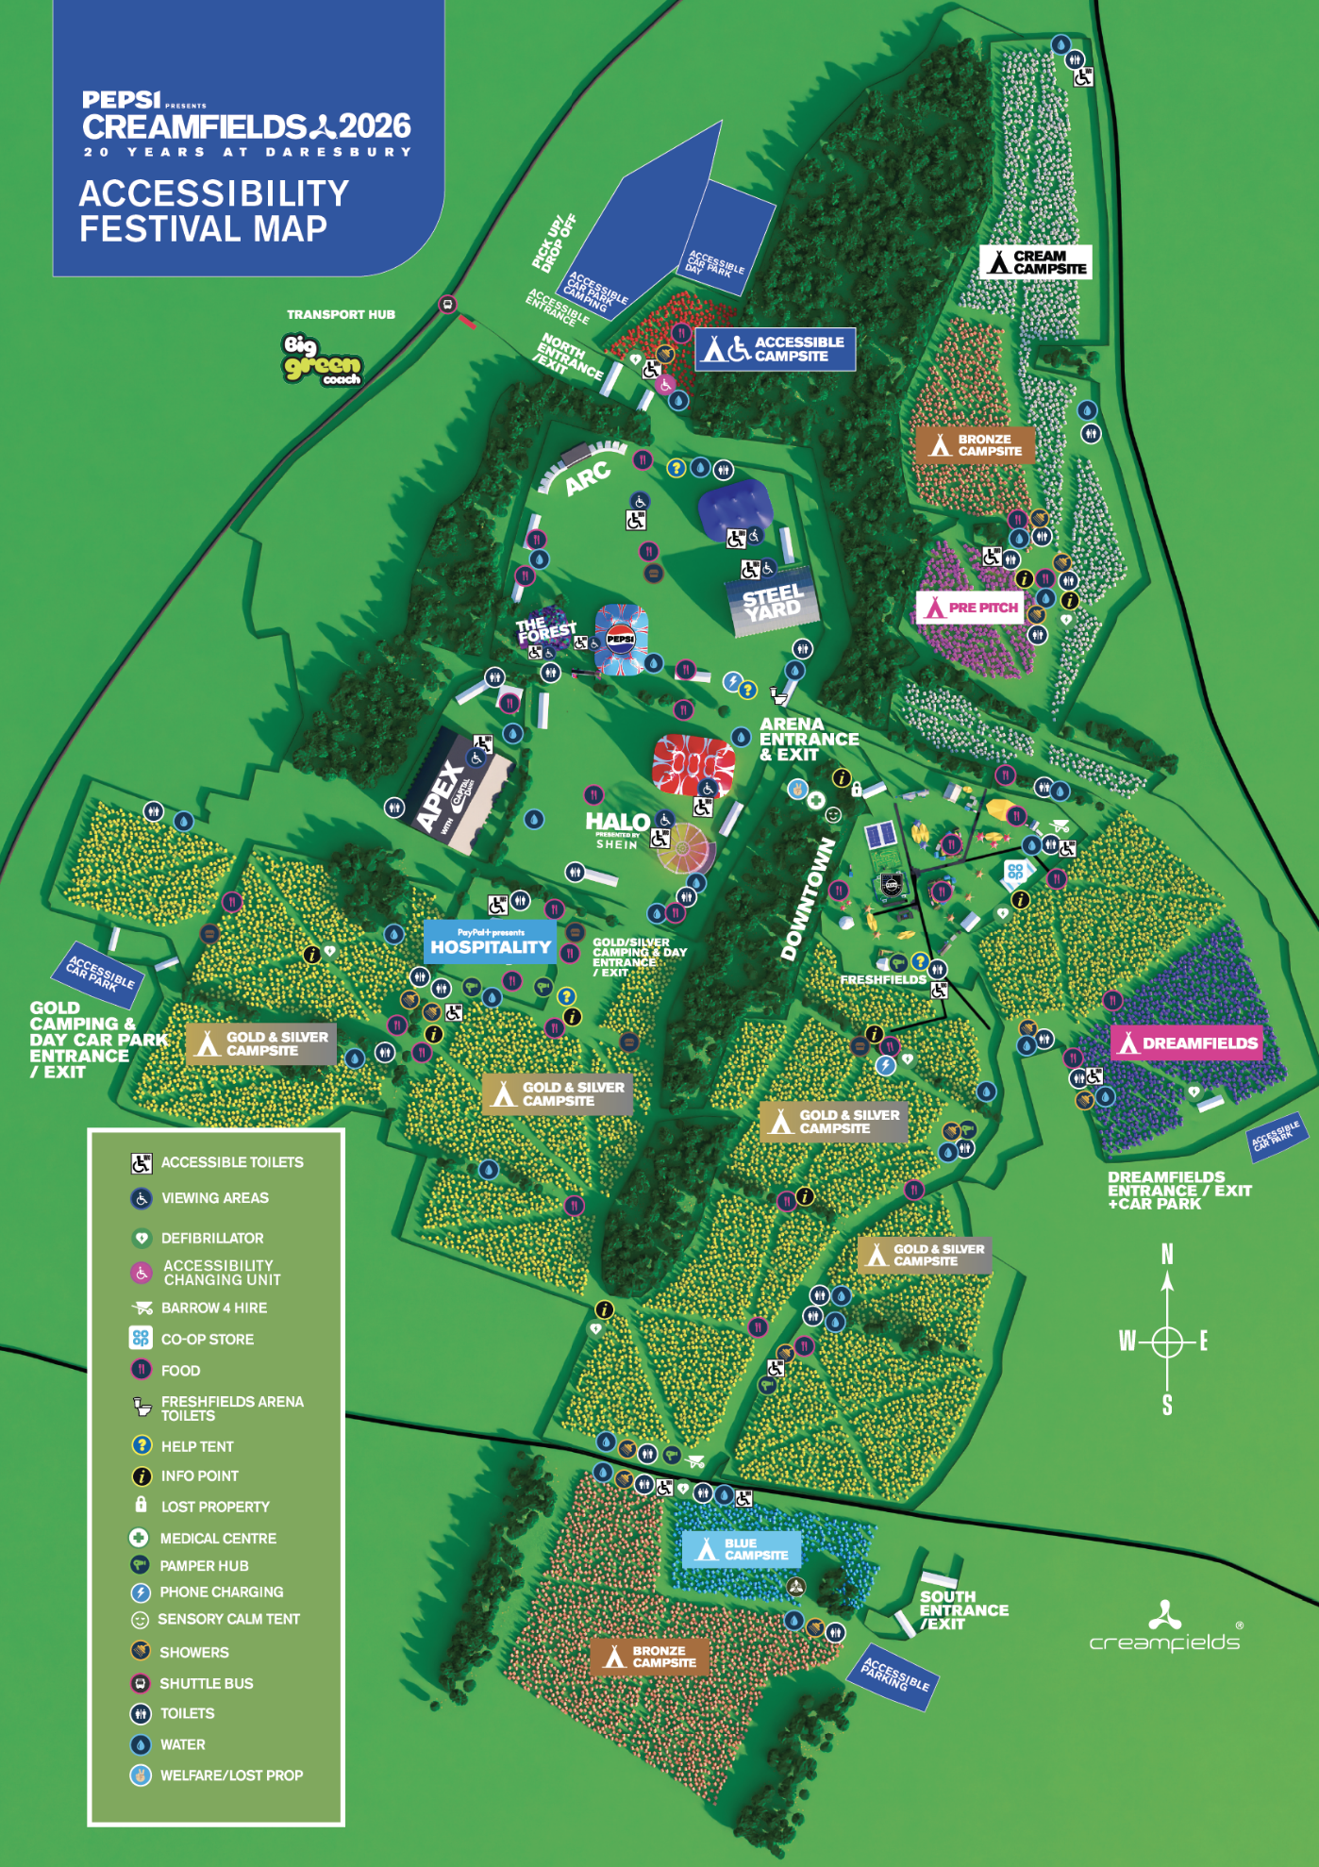
ACCESSIBILITY SITE MAP

